**ABSTRACT**

**Flipkart** is an Indian [e-commerce](https://en.wikipedia.org/wiki/E-commerce) company, headquartered in [Bangalore](https://en.wikipedia.org/wiki/Bangalore), [Karnataka](https://en.wikipedia.org/wiki/Karnataka), India, and incorporated in [Singapore](https://en.wikipedia.org/wiki/Singapore) as a [private limited company](https://en.wikipedia.org/wiki/Private_company_limited_by_shares). The company initially focused on online book sales before expanding into other product categories such as [consumer electronics](https://en.wikipedia.org/wiki/Consumer_electronics), fashion, home essentials, groceries, and lifestyle products.

The service competes primarily with [Amazon](https://en.wikipedia.org/wiki/Amazon.com)'s Indian subsidiary and domestic rival [Snapdeal](https://en.wikipedia.org/wiki/Snapdeal" \o "Snapdeal).As of March 2017, Flipkart held a 39.5% market share of India's e-commerce industry. Flipkart has a dominant position in the apparel segment, bolstered by its acquisition of [Myntra](https://en.wikipedia.org/wiki/Myntra" \o "Myntra), and was described as being "neck and neck" with Amazon in the sale of electronics and [mobile phones](https://en.wikipedia.org/wiki/Mobile_phone).Flipkart also owns [PhonePe](https://en.wikipedia.org/wiki/PhonePe" \o "PhonePe), a [mobile payments](https://en.wikipedia.org/wiki/Mobile_payment) service based on the [Unified Payments Interface](https://en.wikipedia.org/wiki/Unified_Payments_Interface).

In August 2018, U.S.-based retail chain [Walmart](https://en.wikipedia.org/wiki/Walmart) acquired a 77% controlling stake in Flipkart for [US](https://en.wikipedia.org/wiki/United_States_dollar)$16 billion, valuing Flipkart at around $20 billion.[

Table of Contents  
Acknowledgements............................................................................................................. v  
1. Introduction..................................................................................................................... 1  
1.1 Goal........................................................................................................................... 1  
1.2 Need of the application ............................................................................................. 1  
1.3 Scope......................................................................................................................... 2  
1.4 Platform Specifications – Deployment ..................................................................... 2  
1.4.1 Hardware Specification...................................................................................... 2  
1.4.2 Software Specification....................................................................................... 3  
2. System Requirement Analysis ........................................................................................ 3  
2.1 Information Gathering .............................................................................................. 3  
2.2 System Feasibility..................................................................................................... 4  
2.2.1 Economic Feasibility ........................................................................................ 4  
2.2.2 Technical Feasibility.......................................................................................... 4  
2.2.3 Behavioural Feasibility ........................................................................................ 4  
3. System Analysis.............................................................................................................. 5  
3.1 ER Diagram ............................................................................................................. 5  
3.2 Data Flow Diagram................................................................................................... 6  
3.3 Use case Diagram ................................................................................................... 10  
3.4 Class Diagram......................................................................................................... 11  
4. Design ........................................................................................................................... 11  
4.1 Design Goals........................................................................................................... 11  
4.2Architectural Design ................................................................................................ 12  
4.2.1Architectural Context Diagram......................................................................... 12  
4.2.2 Description of Architectural Design ................................................................ 12  
4.3 Procedural/Modular Approach................................................................................ 13  
4.3.1 Shop Products Module..................................................................................... 13  
4.3.2 Product Description Module............................................................................ 13  
4.3.3 Cart Details Module......................................................................................... 13  
5. Implementation ............................................................................................................. 14  
5.1 Database Design and Implementation ................................................................... 14  
5.2 User Interface Design and Implementation ............................................................ 15  
5.3 Technical Discussions............................................................................................. 19  
6. Testing........................................................................................................................... 19  
6.1 Unit Testing ............................................................................................................ 19  
6.2 Integration Testing.................................................................................................. 20  
6.3 Validation Testing................................................................................................... 21  
6.4 White Box Testing ................................................................................................. 22  
6.5 Performance Testing .............................................................................................. 22  
7. Results & Challenges.................................................................................................... 24  
7.1 Challenges............................................................................................................... 25  
8. Conclusions................................................................................................................... 25  
8.1 Limitations .............................................................................................................. 25  
8.2 Scope for Future Work............................................................................................ 26  
9. References..................................................................................................................... 27

**1. Introduction**

All of us love to do online shopping as in this tech world who does not want to get his/her work done while sitting comfortably at home? Shopping and buying necessities have been made less time consuming, less expensive and much easier and comfortable for us by online e-commerce platforms. It could not have been possible if these e-commerce platforms were not available. One of these major platforms is Flipkart which is grabbing a larger share of the e-commerce market. So let us now read some facts about the leading online selling store Flipkart and its co-founders Sachin Bansal and Binny Bansal.

**Introduction:**  
Flipkart is one of India’s leading e-commerce marketplaces. It was founded in October 2007 and its headquarters are in Bengaluru. It was founded by [**Sachin Bansal**](https://en.wikipedia.org/wiki/Sachin_Bansal) and Binny Bansal. This online venture was initially started as an online bookstore and as the popularity of the company grew, it expanded and diversified its operations.

It started selling other items such as music, movies, and mobile phones. As the revolution of e-commerce gained momentum in India, Flipkart grew at an accelerated pace and added several new product lines in its portfolio.

As of now, the company offers 80 million+ products spread across more than 80 categories such as mobile phones & accessories, computers and accessories, laptops, books and e-books, home appliances, electronic goods, clothes and accessories, sports and fitness, baby care, games and toys, jewelry, footwear, and the list goes on.

Flipkart has 100 million registered users and more than a million sellers on its electronic commerce platform. To ensure prompt delivery to its customers, the company has invested in setting up warehouses in 21 states.  
This online platform attracts ten million page hits every day and around eight million shipments are processed every month. Flipkart has also introduced its mobile application, which has become quite popular, with 50 million+ app users. Flipkart is a billion dollar company and its valuation in 2016 was INR 15,129 crore (US$2.3 billion). It is also fulfilling its social responsibility by providing huge scale employments (employs more than 33,000 people).

## ****Background History of Flipkart****

Flipkart was originally started as an online book store in October 2007. To start Flipkart, the founders Sachin Bansal and Binny Bansal left their jobs at Amazon and took a huge risk to start a venture of their own. When the founders thought of starting Flipkart as a company the market at that time was not so much vibrant and was not adapted to the e-Commerce sector that much.

This means e-commerce in India was mostly non-existent at that time and there was no certainty about its future. Still, the Bansals decided to take this risk and now it has turned out to be a huge success.

One of the major problems that **[Flipkart](https://www.flipkart.com/)** tackled during its initial years was online payments because at that time, people in India were averse to make online payments to a virtual store, due to fear of frauds and loss of money.

* 1. **Goal:**

Flipkart’s merchandising section (including Myntra) as well as its electronics segment is a Star in the [BCG matrix](https://www.marketing91.com/bcg-matrix/). The reason is that the segment is growing and more & more customers are getting accustomed with online buying of clothes & electronics items in India. But as the market is huge, the [market share](https://www.marketing91.com/market-share-definition/) is less for each E-commerce player and they are fighting hard for it.

All other segments are question mark due to intense competition between the players. [Profitability](https://www.marketing91.com/customer-profitablity-analysis-2/) is low overall so the future is unknown.

Having its own [distribution](https://www.marketing91.com/distribution-definition/) firm (Ekart) and payment gateway payzippy has helped the company in controlling its expenses and passing the benefits to the end customer.

The very demerit of Flipkart’s distribution [channel](https://www.marketing91.com/channel-levels-consumer-industrial-marketing-channels/) is its reach as compared to the peer E-commerce companies like Amazon, Snapdeal [Ebay](https://www.marketing91.com/marketing-mix-of-ebay/) etc who can deliver the customer’s order even to the remote locations.

One more problem of Flipkart is that it does not support sellers with package size of above 8 kgs. You have to use flipkart advantage for the same.

## ****Brand equity in the Marketing strategy of Flipkart****

Flipkart have garnered a [market leader](https://www.marketing91.com/7-strategies-of-market-leaders/) position through its innovative [branding](https://www.marketing91.com/branding-started/) strategies. The “big billion day”, “ No Kidding, No Worries”, “Fair-Tale”,  “Shopping ka Naya Address” , “Shop Anytime, Anywhere” are the successful campaigns that helped the company in creating top of the mind awareness. Flipkarts brand valuation is a **whopping $15 billion by 2015.**

Different mediums i.e. [twitter](https://www.marketing91.com/marketing-mix-twitter/), [facebook](https://www.marketing91.com/marketing-strategy-facebook/), TV commercials and promotion of mobile app shopping have helped Flipkart in becoming a household name in the [target market](https://www.marketing91.com/target-market-find-one/).

**1.2 Need of the application**There are large numbers of commercial Online Shopping websites offering large number

of products tailored to meet the shopping interests of large number of customers. These

online marketplaces have thousands of products listed under various categories.

**Problem:**

• The basic problems with the existing systems are the non-interactive environment

they provide to the users.

• The use of traditional user interfaces which make continuous post backs to the

server; each post back makes a call to the server, gets the response and then

refreshes the entire web form to display the result. This scenario adds an extra

trade off causing a delay in displaying the results

• A search engine that would display the results without allowing the users to

further filter the results based on various parameters.

• Use of traditional and non user friendly interfaces that are hard to use

**Solution:**

• The motive of this Online Shopping Web Application is to allow the user to play

with the search tool and create different combinatorial search criterion to perform

exhaustive search.

• Making the application AJAX enabled gets rid of these unnecessary delays letting

the user to perform exhaustive search. The users of this application can easily feel

the difference between the Ajax empowered user interfaces vs. traditional user

interfaces.

• Provide Interactive interface through which a user can interact with different areas

of application easily.

• A search engine that provides an easy and convenient way to search for products

specific to their needs. The search engine would list a set of products based on the

search term and the user can further filter the list based on various parameters.

• Provide Drag and Drop feature thereby allowing the user to add products to or

remove products from the shopping cart by dragging the products in to or out of  
the shopping cart.  
.  
**1.3 Scope**

The current system can be extended to allow the users to create accounts and

save products in to wish list.

• The users could subscribe for price alerts which would enable them to receive

messages when price for products fall below a particular level.

• The current system is confined only to the shopping cart process. It can be

extended to have a easy to use check out process.

• Users can have multiple shipping and billing information saved. During

checkout they can use the drag and drop feature to select shipping and billing information.

**1.4 Platform Specifications – Deployment**

**1.4.1 Hardware Specification**Operative System: Windows  
Hard Disk: 40 GB  
RAM 250 MB  
Processor : Pentium(R)Dual-core CPU

Display 16 bit color

**1.4.2 Software Specification  
Software Specification**

Operating Environment Win 2000/XP

Platform .Net Framework & IIS Visual Studio 2008

Database SQL Server 2005

**4. System Features**

* The website authority should ensure the customer provide real product.
* Customer support is available from the authority
* Customer information security confirm.
* Manage customer information.
* To increase efficiency of managing the authority work

***2.1 Information Gathering***

As the goal of the application is ease of use and to provide an interactive

interface, extensive research has been done to gain an insight into the needs and

behaviors of various users. The working of the application is made convenient and easy to use for the end user. Dr Andresen, Associate Professor, CIS provided regular feedback

on the project.

Users can be classified into two types based on their knowledge of the products

that suit their needs. They can be classified as users who know about the product that

would satisfy their needs and users who have to figure out the product that would satisfy

their needs. Users who know about the product should be able to find the product easily

with the click of a button. Such users can search for the product by using the product

name as the search term. Users who have to figure out the product that would satisfy their

needs could use a search term to find a list of products and then should be able to filter

the results based on various parameters like product type, manufacturer, price range,

platform supported etc.

The users should be able to view the complete specification of the product and

various images at different Zoom levels. The user should be able to read the customer

reviews for the product and the ratings provided. They should be able to write their own

reviews. They should be able to print out the specifications for a product or email the

product page to a friends etc.

To increase the ease of use the user should be able to add a product to the

shopping cart by dragging a product and dropping it in the shopping cart. A user shouldable to edit the contents of a shopping cart. They should be able to update the quantities of the products added to the cart and remove the products from the cart. The user should be able to remove the product from the shopping cart by dragging the product and

dropping it outside the cart.The application can be made interactive by pop up messages when a product has been dropped in to the shopping cart or out of the shopping cart. The user can be notified

**2.2 System Feasibility**

The system feasibility can be divided into the following sections:

**2.2.1 Economic Feasibility**

The project is economically feasible as the only cost involved is having a

computer with the minimum requirements mentioned earlier. For the users to access the

application, the only cost involved will be in getting access to the Internet.

**2.2.2 Technical Feasibility**

To deploy the application, the only technical aspects needed are mentioned below:

Operating Environment Win 2000/XP

Platform .Net Framework & IIS

Database SQL Server 2005

**For Users:**

Internet Browser

Internet Connection

**2.2.1 Economic Feasibility**

The project is economically feasible as the only cost involved is having a  
computer with the minimum requirements mentioned earlier. For the users to access the  
application, the only cost involved will be in getting access to the Internet.  
 **2.2.2 Technical Feasibility**To deploy the application, the only technical aspects needed are mentioned below:  
Operating Environment Win 2000/XP  
Platform .Net Framework & IIS  
Database SQL Server 2005

**For Users:**

Internet Browser  
Internet Connection

**2.2.3 Behavioral Feasibility**

The application requires no special technical guidance and all the views available  
in the application are self explanatory. The users are well guided with warning and failure  
messages for all the actions taken.  
  
**3. System Analysis:**

After carefully analyzing the requirements and functionality of the web  
application, I had two important diagrams by the end of the analysis phase. They are the  
ER diagram and data flow diagram which were the basis for finding out entities and  
relationships between them, the flow of information.

**3.1 ER Diagram**

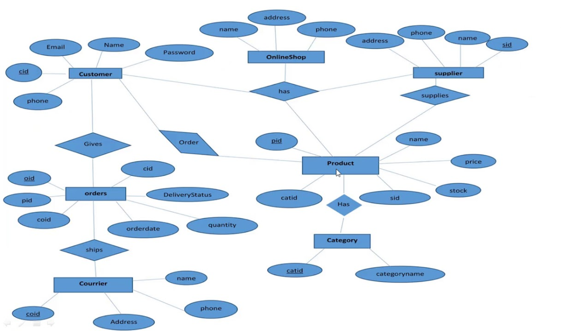

**3.2 Data Flow Diagram**

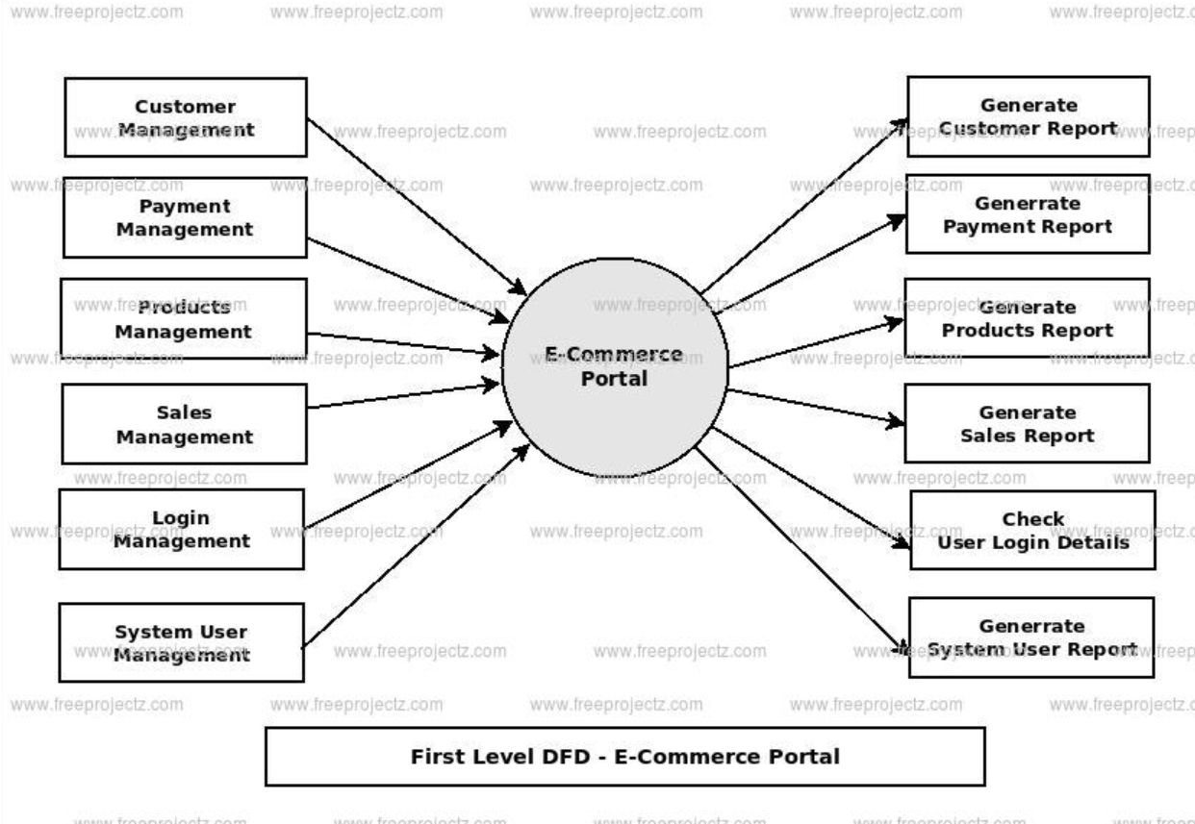

**3.3 Use Case Diagram**

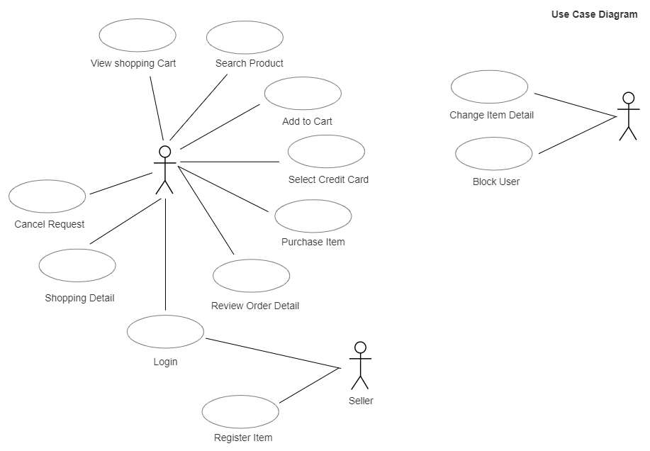

**3.4 Class Diagram**

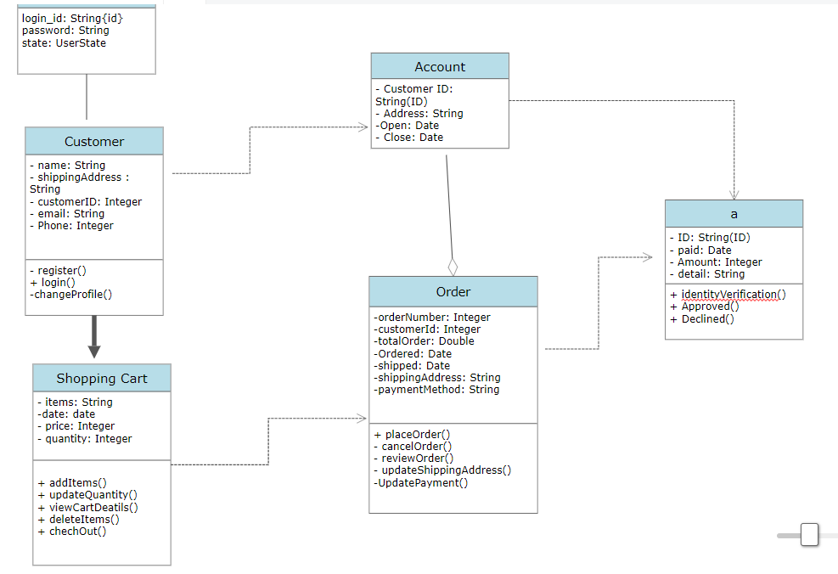

**3.5 Package Diagram**

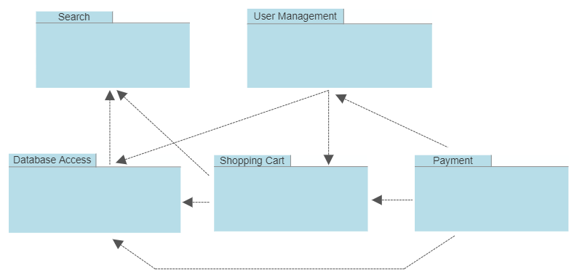

**3.6 Deployment Diagram**

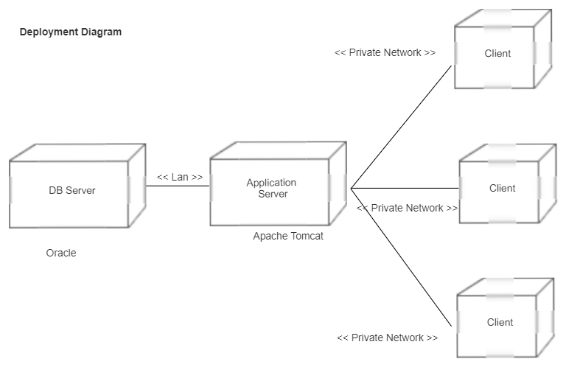

**4. Design**

**4.1 Design Goals**

• The design of the web application involves the design of the forms for listing the  
products, search for products, display the complete specification for the product,  
and design a shopping cart that is easy to use.  
• Design of an interactive application that enables the user to filter the products  
based on different parameters.  
• Design of an application that has features like drag and drop etc.  
• Design of application that decreases data transfers between the client and the  
server.  
  
**4.2 Architectural Design**

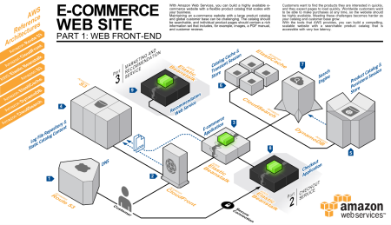

**Part 1: Web Front End**

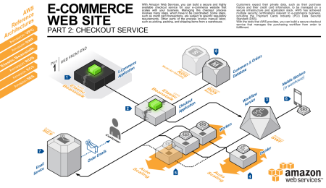

**Part 2: Checkout Service**

**4.2.1 Architectural Context Diagram**

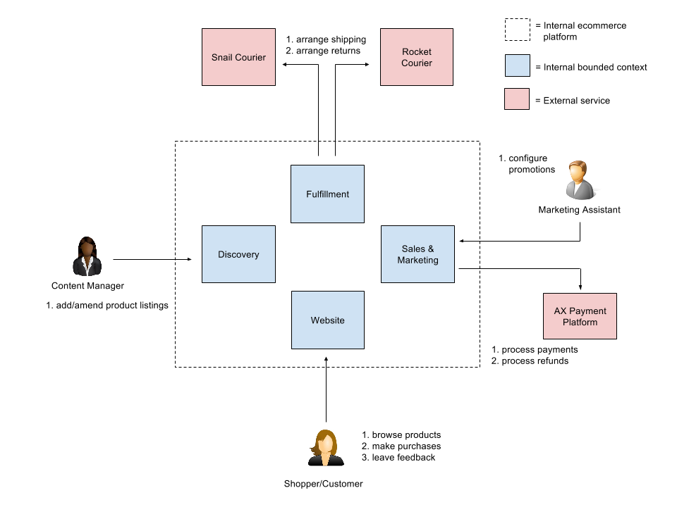

**Figure 4.1 Architectural Context Diagram**

**4.2.2 Description of Architectural Design**

## When to Use Context Diagram?

Of great importance to project stakeholders, the **system context diagram** draws all attention to external factors and events to consider in designing a whole set of a system’s restrictions and requirements. It is essential at the beginning of a project to help decipher the project domain you are investigating.

A **system context diagram** represents all the external components that may interact with the system, hence displays the entire software system as a unit. This type of chart puts the system in the middle and surrounds it with its external parts, associated entities, and surroundings. Details of the interior structure of the system are explicitly left out.

Also, a **context diagram** can be used to reduce risks in a project greatly. Since they are mostly useful for the business partners in a project, they are very keen to spot high-level design bloopers that would have otherwise cost them a plan. Hence reviewing a **context diagram** is useful in setting the project’s budget correctly.

**4.3 Procedural/Modular Approach**

1. **Identify the product/service, and the customer  
2. Choose the right ecommerce website development platform  
3. Choose the right ecommerce website hosting platform  
4. Choose the right ecommerce development partner  
5. Ecommerce website testing – You can never test enough  
6. Effective marketing  
7. Adapt and grow**

**Following are all the modules designed for the Online Shopping System.**

**4.3.1 Shop Products Module**

For those of you with erratic working hours, **Flipkart** is your best bet. **Shop** in your PJs, at night or in the wee hours of the morning. This e-commerce never shuts down. What's more, with our year-round shopping festivals and events, our prices are irresistible. We're sure you'll find yourself picking up more than what you had in mind. ... In an attempt to make high-end **products** accessible to all, our No Cost EMI plan enables you to **shop** with us

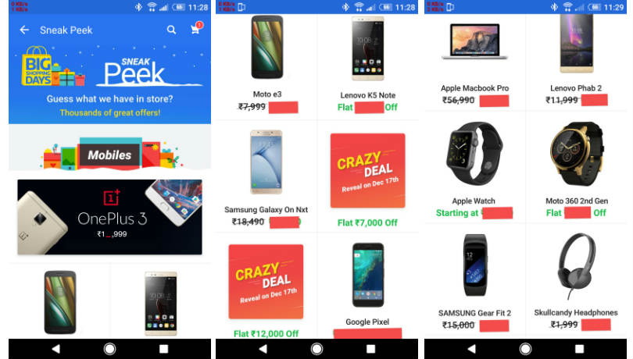

**4.3.2 Product Description Module**

Our catalog partners develop high-quality photographs of your **products** and crisp **product descriptions** for your **product** catalog. A good catalog gives your customers a better understanding of your **products** and helps boost your sales. ... When pricing **products** on **Flipkart**, please account for the applicable Marketplace Fee and include a suitable margin to arrive at the Selling Price.

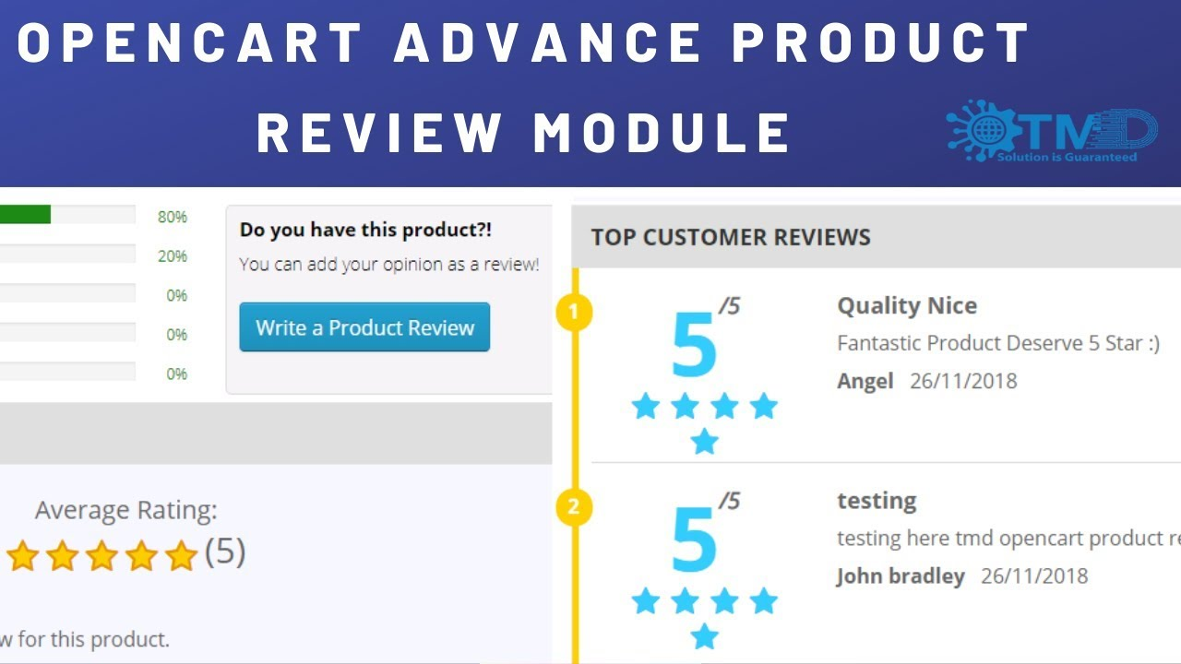

**4.3.3 Shopping Cart Module**

All you need is 500 supercoins to be a part of this service. For every 100 rupees spent on **Flipkart** order, Plus members earns 4 supercoins & non-plus members earn 2 supercoins. Free delivery, early access during sales and **shopping** festivals, exchange offers and priority customer service are the top benefits to a **Flipkart** Plus member. In short ... quantity of a product or when a product is removed from the cart.

**Flipkart** Mobile Apps for Online **Shopping** - Download the Most Trusted Online **Shopping** Mobile App to enhance your online **shopping** experience on your Android, iPhone & Windows Devices. **Flipkart** is India's largest e-commerce store with millions of products online. Explore Plus. Login. More. **Cart**. INDIA'S MOST POPULAR! **SHOPPING** APP. Genuine Products. Secure **Shopping**. Hassle - free Returns. Download the **Flipkart** mobile app.

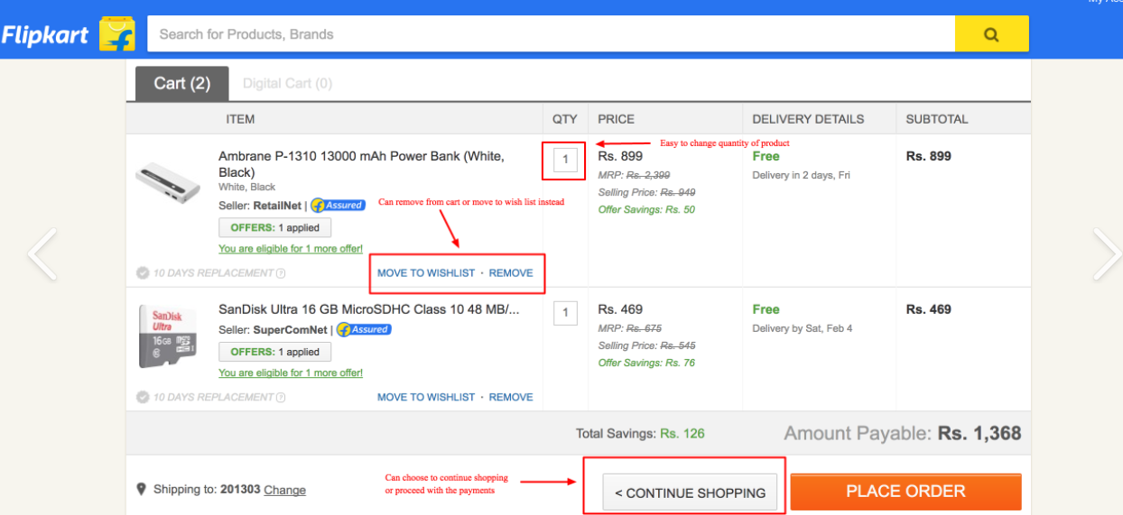

**5. Implementation**

**5.1 Database Design and Implementation**

The design of the database was similar to the analysis phase. The database has been  
developed using SQL Server 2005.  
Figure 5.1 Database Implementation using SQL Server 2005  
These are the main tables in the application and others are lookup and query tables. The  
tables were derived from the ER-Diagram.  
  
**5.2 User Interface Design and Implementation**

The **user** experience and technology have always been core expertise of **Flipkart**. The website loads faster and is mobile-optimised and offers hassle-free **user** experience. ... The special shout out goes to the graphic **design** team that creates a custom cover page for each occasion, topic and trend- aligned with **Flipkart**’s colour tonality and language. ... CTAs driving the customers away. Amazon, its arch-nemesis, on the other hand.

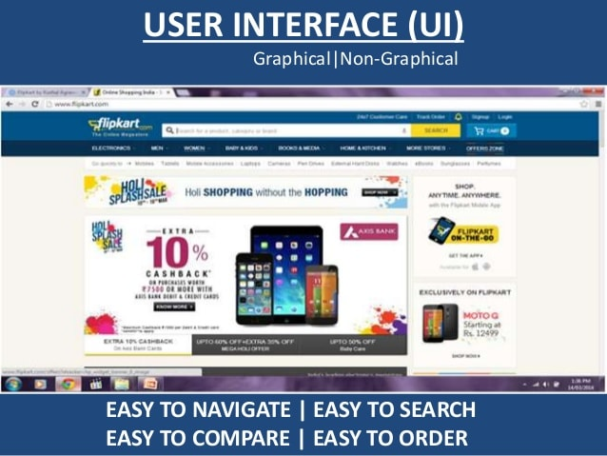

**5.3 Technical Discussion**

The products can be filtered based on various parameters like Manufacturer,  
Product Type, Operating System supported etc. Initially it was decided to have the  
various list items predefined. But with time new manufacturers and product types could  
be added. So the values for the list of manufacturers and product types are loaded  
dynamically by retrieving from the database. Also it was decided initially to have a drop  
down list for price range and the user could select a price range from the ranges available.  
But this would limit the user’s ability to filter the products based on different price  
ranges. Instead providing two text fields so that the user can enter their price range would  
give them more flexibility.  
A product could be added to a shopping cart by dragging it and dropping it in the cart  
area. Items in the cart could be removed by clicking a button. To maintain symmetry and  
ease of use products could be removed from the cart by dragging the product out of the  
cart.  
A product can be added to the cart by dragging it and dropping it in the cart.  
Initially it was decided that when a product is dropped in the cart the cart summary label  
could be updated on the client side without any call to the server and later the session  
variables (Shopping cart) could be updated. This would result in loss of information when  
the user loses internet connection. So when a product is dropped in the cart area a web  
service is called and this service updates the session variables for the shopping cart and  
the cart summary is recalculated and sent back to the client. This would improve the  
reliability of the application.

**6. Testing**

There are many different types of testing that you can use to make sure that changes to your code are working as expected. Not all testing is equal, though, and we will see here how the main testing practices differ from each other.

## Manual vs. automated testing

At a high level, we need to make the distinction between manual and automated tests. Manual testing is done in person, by clicking through the application or interacting with the software and APIs with the appropriate tooling. This is very expensive as it requires someone to set up an environment and execute the tests themselves, and it can be prone to human error as the tester might make typos or omit steps in the test script.

Automated tests, on the other hand, are performed by a machine that executes a test script that has been written in advance. These tests can vary a lot in complexity, from checking a single method in a class to making sure that performing a sequence of complex actions in the UI leads to the same results. It's much more robust and reliable than automated tests – but the quality of your automated tests depends on how well your test scripts have been written. If you're just getting started with testing, you can read our continuous integration tutorial to help you with your first test suite. Looking for more testing tools? Check out these [DevOps testing tutorials](https://www.atlassian.com/devops/automation-tutorials).

Automated testing is a key component of [continuous integration](https://www.atlassian.com/continuous-delivery/continuous-integration/how-to-get-to-continuous-integration) and [continuous delivery](https://www.atlassian.com/continuous-delivery/pipeline) and it's a great way to scale your QA process as you add new features to your application. But there's still value in doing some manual testing with what is called exploratory testing as we will see in this guide.

## The different types of tests

### **Unit tests**

Unit tests are very low level, close to the source of your application. They consist in testing individual methods and functions of the classes, components or modules used by your software. Unit tests are in general quite cheap to automate and can be run very quickly by a continuous integration server.

### **Integration tests**

Integration tests verify that different modules or services used by your application work well together. For example, it can be testing the interaction with the database or making sure that microservices work together as expected. These types of tests are more expensive to run as they require multiple parts of the application to be up and running.

### **Functional tests**

Functional tests focus on the business requirements of an application. They only verify the output of an action and do not check the intermediate states of the system when performing that action.

There is sometimes a confusion between integration tests and functional tests as they both require multiple components to interact with each other. The difference is that an integration test may simply verify that you can query the database while a functional test would expect to get a specific value from the database as defined by the product requirements.

### **End-to-end tests**

End-to-end testing replicates a user behaviour with the software in a complete application environment. It verifies that various user flows work as expected and can be as simple as loading a web page or logging in or much more complex scenarios verifying email notifications, online payments, etc...

End-to-end tests are very useful, but they're expensive to perform and can be hard to maintain when they're automated. It is recommended to have a few key end-to-end tests and rely more on lower level types of testing (unit and integration tests) to be able to quickly identify breaking changes.

### **Acceptance testing**

Acceptance tests are formal tests executed to verify if a system satisfies its business requirements. They require the entire application to be up and running and focus on replicating user behaviours. But they can also go further and measure the performance of the system and reject changes if certain goals are not met.

### **Performance testing**

Performance tests check the behaviours of the system when it is under significant load. These tests are non-functional and can have the various form to understand the reliability, stability, and availability of the platform. For instance, it can be observing response times when executing a high number of requests, or seeing how the system behaves with a significant of data.

Performance tests are by their nature quite costly to implement and run, but they can help you understand if new changes are going to degrade your system.

### **Smoke testing**

Smoke tests are basic tests that check basic functionality of the application. They are meant to be quick to execute, and their goal is to give you the assurance that the major features of your system are working as expected.

Smoke tests can be useful right after a new build is made to decide whether or not you can run more expensive tests, or right after a deployment to make sure that they application is running properly in the newly deployed environment.

There are three main components  
- Validation test criteria (no. in place of no. & char in place of char)  
- Configuration review (to ensure the completeness of s/w configuration.)  
- Alpha & Beta testing-Alpha testing is done at developer’s site i.e. at home & Beta  
testing once it is deployed. Since I have not deployed my application, I could not do the  
Beta testing.

Test Cases-  
I have used a number of test cases for testing the product. There were  
different cases for which different inputs were used to check whether desired output is  
produced or not.  
1. Addition of a new product to the cart should create a new row in the shopping  
cart.  
2. Addition of an existing product to the cart has to update the quantity of the  
product.  
3. Any changes to items in the cart have to update the summary correctly.  
4. Because same page is inserting data into more than one table in the database  
atomicity of the transaction is tested.  
5. The state of the system after a product has been dragged in to the cart should be  
same as the state of the system if the same product is added to the cart by clicking  
a button.

**Factors affecting Response Time:**• Limited System Hardware Resources (CPU, RAM, Disks) and Configuration  
• JMeter Tests and Application running on the same machine.

Remote Testing:  
Users Loop Count Ramp Up  
period(sec)  
Cart Details  
Page(ms)  
Shop Products  
page(ms)  
100 150 10 792 8312  
500 150 10 6392 99069  
1000 150 10 20457 227056  
Observations:  
Response Time of a complex webpage with database and business logic functions is far  
more than a simple webpage. The Response times of remote testing are better than those  
of local testing when the number of users is comparatively lesser.  
Factors affecting Response Time:  
• Better Hardware Resources (CPU, RAM, Disks) and Configuration for the  
Application as it was hosted on a web server.  
• JMeter had better access to hardware resources as the application is not on the  
same machine.

Using this above tabular data, I can say that the system is adequate to handle the normal  
load and the users won’t lose their focus.

**7. Results & Challenges**

The application can be used for any Ecommerce application. It is easy to use, since it  
uses the GUI provided in the user dialog. User friendly screens are provided. The  
application is easy to use and interactive making online shopping a recreational  
activity for users. It has been thoroughly tested and implemented.  
7.1 Challenges  
• Compatibility with browsers like Mozilla Firefox, Internet explorer etc  
• Using a layered approach in developing the application which would make the  
application maintainable.

• Learning new technologies like using JavaScript for drag and drop behavior and  
Ajax toolkit controls with little guidance.  
The overall idea of doing this project is to get a real time experience. Learn new  
technologies.  
8. Conclusions

The ‘Online Shopping’ is designed to provide a web based application that would make  
searching, viewing and selection of a product easier. The search engine provides an easy  
and convenient way to search for products where a user can Search for a product  
interactively and the search engine would refine the products available based on the  
user’s input. The user can then view the complete specification of each product. They can  
also view the product reviews and also write their own reviews. Use of Ajax components  
would make the application interactive and prevents annoying post backs. Its drag and  
drop feature would make it easy to use.

**8.1 Limitations**

This application does not have a built in check out process. An external checkout  
package has to be integrated in to this application. Also users cannot save the shopping  
carts so that they can access later i.e. they cannot create wish lists which they can access  
later. This application does not have features by which user can set price ranges for  
products and receive alerts once the price reaches the particular range.  
26  
**8.2 Scope for Future Work**

## Big push into the sub-$100 smartphone category

Flipkart has been busy adding new products on its platform, especially over the last 12 to 24 months, and today has over 70 categories. While electronic accessories topped the list of categories in terms of number of orders, mobile is still king for Flipkart and by extension for the e-commerce industry. Flipkart claims that one out of every five mobile phones sold in the country is sold on its platform.

## Reduce dependence on phone category

Mobile might be their largest category, but that does not mean Flipkart does not want to grow other types of products. It has launched new categories this year like car accessories and furniture. It has also focused heavily on fashion ever since its acquisition of [Myntra](https://yourstory.com/2015/12/new-myntra_2-0/amp/) in 2014. This has surely shown results. After electronic accessories and mobiles, the biggest categories for the eight-year-old company are lifestyle accessories, women’s clothing and men’s clothing.

In fact, last year men’s clothing as a category was larger than women’s. While almost 70 per cent of user accounts on the platform are of men, 40 per cent of merchandise sold on Flipkart are women related. **Sarees are among the top sellers in fashion, with 20 per cent month-on-month growth. Ankit said sellers based in Surat get 20,000 saree orders a day on the platform.** Next year, Ankit expects, women’s clothing, furniture and large appliances to come into their own.  Of this, furniture is one of the segments the company is betting heavily on. Ankit said the supply chain is ready and has been tested with large appliance category. “With our combination of supply chain and Jeeves, we are hoping furniture will do very well next year,” he said. The company had acquired repairs and maintenance company Jeeves last October.

**9.** **References**<https://papers.ssrn.com/sol3/papers.cfm?abstract_id=2960044>

<http://sdmimd.net/dimensions/issue/septoct2016/6_Flipkart.pdf>